METRO TICKET BOOKING SYSTEM
2 Requirement Analysis

2.1 Functional Requirements

Passenger Module
- Book metro tickets
- View ticket history
- Make payments
- View QR tickets
- Raise complaints
- Receive notifications

Student Module
- Register student profile
- Apply for student passes
- View pass status
- Renew student passes
- Receive verification notifications

Metro Admin Module
- Monitor bookings
- Verify student profiles
- Manage complaints
- Track payments and revenue
- Access dashboards and reports

Finance Admin Module
- Monitor payment transactions
- Track revenue
- Generate financial reports

Station Staff Module
- Validate QR tickets
- View travel/pass details
- Assist passengers

2.2 Service Types / Functional Modules

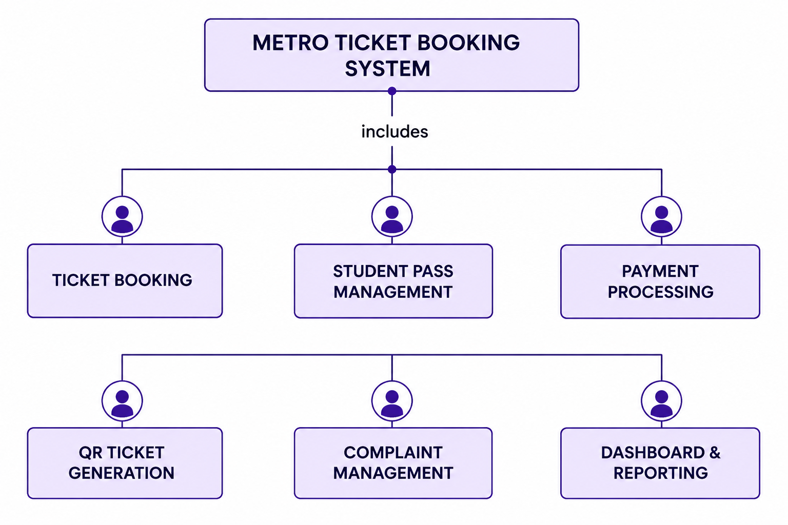

Metro Ticket Booking – Book tickets using source, destination, date and passenger count.
Student Pass Management – Apply, verify, activate and renew student passes.
Payment Processing – Manage booking and pass payments.
QR Ticket Generation – Generate QR tickets after successful payment.
Complaint Management – Raise and track complaints.
Dashboard & Reporting – Monitor bookings, revenue, passes and complaints.

2.3 Stakeholders

Stakeholder | Responsibility
Passenger | Book tickets and raise complaints
Student | Apply and manage student passes
Station Staff | Validate QR tickets
Finance Admin | Manage payments and revenue
Metro Admin | Manage entire system
ServiceNow Admin | Maintain application and platform

